**ORXe Tooltip Component**

### Document Properties

| Item | Details |
| --- | --- |
| Document | Technical Specification Document |
| Application | ORXe Tooltip Component |
| Author | Sneha Waje |
| Creation Date | 20/9/2020 |
| Last Updated | 20/9/2020 |
| Status | Completed |

Contents

Document Properties 1

1. Component Overview 3

1.1 Objective 3

1.2 Use Cases 3

1.3 Risks 3

1.4 Out of Scope 4

1.5 Diagram 4

2. Technical Specifications 4

2.1 NPM details 4

2.2 NPM Repository 5

3.Unit Testing 5

4. Assumptions 6

5. Concerns and Issues 6

1. Component Overview

This document provides a technical details of a reusable tooltip component. Tooltip is used in order to show additional information.

1.1 Objective

Tooltip provides additional help or defines an item/term. It may be used on the label of a UI element, or on a word embedded in a paragraph.

1.2 Use Cases

This component shows basic view show to show information in the form of tooltip.

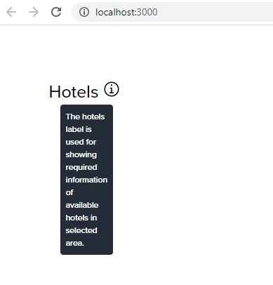

1.3 Risks

N.A.

1.4 Out of Scope

There are no custom animations provided.

1.5 Diagram

There are no custom animations provided.

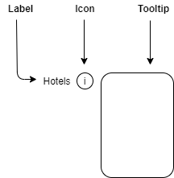

2. Technical Specifications

For tooltip text : @property({ type: String })

|  |  |
| --- | --- |
| **Properties** | **Value** |
| background-color | var(--primary-text) |
| color | var(--neutral) |
| font | var(--global-font-family) |
| line-height | var(--line-height) |
| font-size | var(--caption-font-size) |
| font-weight | var(--font-weight-regular) |
| letter-spacing | 0px |
| margin-left | 16px |
| margin-right | 16px |
| min-height | 54px |
| animation-timing-function | cubic-bezier(0.42, 0, 0.58, 0) |

2.1 NPM details

|  |  |
| --- | --- |
| **Package** | **Version** |
| orxe3/cli | V2.0.20 |
| orxe-components/icon | 1.0.14 |
| orxe-components/icons | 1.0.9 |

Following are installation commands:

* To install ORXe CLI : **npm install -g @orxe3/cli**
* To generate new component workspace : **orxe new cw tooltip-component**
* To generate new component : **orxe generate c tooltip**
* To run application : **orxe serve**
* To run test cases : **orxe test --coverage**
* To publish: **npm publish**
* To reuse component: **npm install @tooltip-assignment/tooltip@0.0.1**

Selector: <orxe-tooltip></orxe-tooltip>

2.2 NPM Repository

<https://packages.common.cnxloyalty.com/service/rest/repository/browse/npm-stage-hosted/>

3.Unit Testing

Testing Unit test cases written for tooltip component

Total test cases: 3

Screenshot for unit test cases –

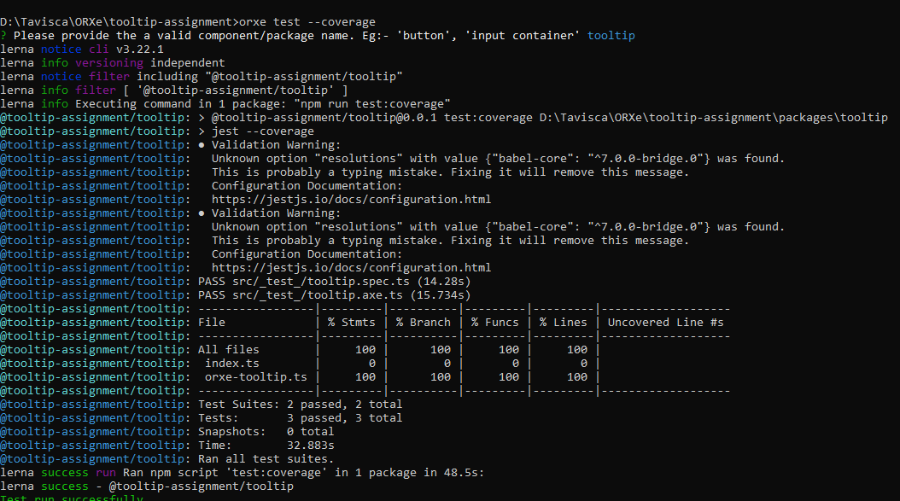

4. Assumptions

I have developed this component based on guidelines given on Confluence page.

5. Concerns and Issues

As NPM registry used is different to publish basic components, ORXe icons not visible due to access issue in npm-stage-hosted.

I have used ‘ic-information’ icon but not rendered as commented as of now.